01 - Data Visualization Scavenger Hunt

Q. Find five examples of data visualizations in everyday life (e.g., ads, maps, packaging, news, mobile apps).
- Diversify the types of data, the context, or the style of visual presentation.
- For each example, briefly describe what data is being shown and how the visualization helps (or doesn't help) convey the information.
- Focus on observation rather than critique!
DELIVERABLE: A short document with images and descriptions of the visualizations and a brief explanation for each (50–100 words per example). USE PDF or DOC. Let us know if you have trouble uploading it.

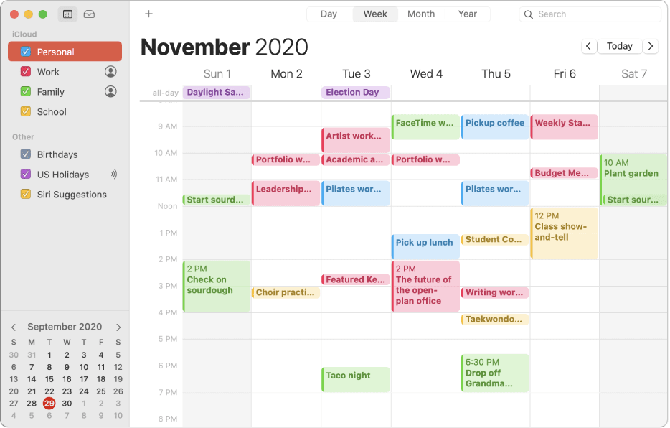
- Calendar Apps

- Example: Google Calendar or Microsoft Outlook Calender or Apple Calender
- Data Shown: Scheduled events, meetings, reminders, and tasks.
- Explanation: Visual layouts in calendar apps display dates and times in a grid format with different events categorized by color and symbols. This helps users quickly see their daily, weekly, or monthly schedules, manage their time efficiently, and stay organized.

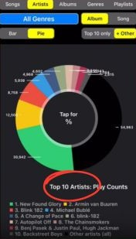
- Music Streaming Apps
- Example: Spotify or Amazon Music, itunes.
- Data Shown: Listening history, top artists, favorite genres, playlist statistics.
- Explanation: Music streaming apps use visualizations such as bar charts and pie charts to show users their listening habits, top artists, and favorite genres. This enhances user engagement by providing personalized insights and statistics about their musical preferences.

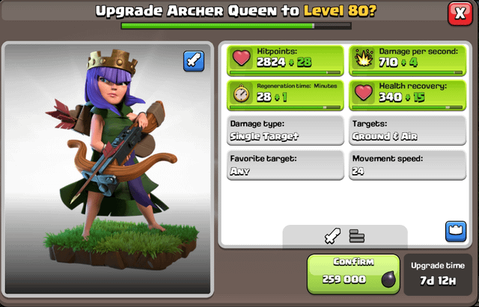
- Gaming Consoles
- Example: Xbox or PlayStation dashboards.
- Data Shown: Game stats, achievements, progress bars.
- Explanation: Gaming consoles use visual dashboards and progress bars to display the player achievements, game stats, and progression through various levels. These visualizations help the gamers track their performance, complete challenges, and stay motivated by seeing the progress of their own.

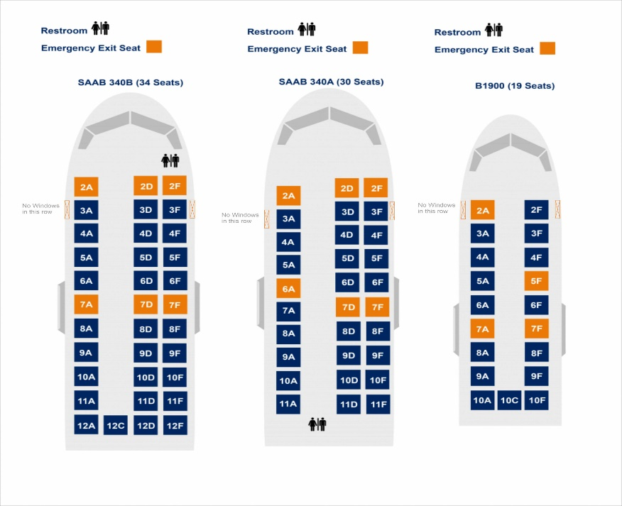
- Flight Seat Maps:

- Example: Airlines like Delta or American Airlines.
- Data Shown: Seat availability, seat types (aisle, window, middle), extra legroom, occupied/free seats.
- Explanation: Airline websites or apps often provide a seating chart where passengers can select available seats for their flight. Color-coded seating charts help passengers easily select their preferred seats by highlighting available (green) and occupied (red) seats, along with special seat types.

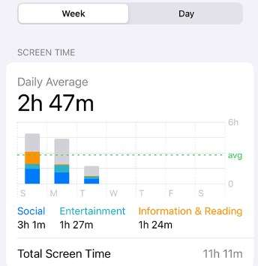
- Smartphone Screen Time

- Example: Screen time reports in iOS or Android settings.
- Data Shown: Daily/weekly screen time, app usage, categories of app usage (productivity, social, entertainment), and pickups.
- Explanation: Screen time visualizations use bar charts to show how much time you spend on different apps and activities. They help users monitor and manage their device usage, promoting healthier screen habits.

Bonus Points
- Select one of the visualizations that you think could be displayed differently and present a mockup of that visualization. No need to use programming.

Smartphone Screen Time (Pie Chart)

- Example: Screen time reports in iOS or Android settings.
- Data Shown: Percentage of total screen time spent on different categories of apps (e.g., Info, social, entertainment).
- Explanation: The pie chart breaks down the total screen time into segments representing various app categories. Each segment's size corresponds to the proportion of time spent on that category. This visualization helps users quickly understand which types of apps they spend most of their time on, promoting better management of screen habits.

